Catching stars that go BANG!

About once a century in any galaxy, a star spontaneously explodes—so brilliant that for a few days it can outshine all other stars in a small home galaxy. Although frequent by cosmic standards, supernovae are rare in human terms: since the invention of the telescope, none has been seen to explode in our Milky Way.
So how can astronomers study such catastrophic stellar suicides, especially the hours immediately after ignition?
Answer: Partner two automated telescopes with real-time supercomputing to monitor tens of thousands of galaxies every night, so that statistically there’s a high chance of spotting a star exploding in some galaxy.
“Just since April 2009, we’ve discovered over 1,300 supernovae!” exclaimed Peter Nugent, senior staff scientist at Lawrence Berkeley National Laboratory and principal investigator of the Palomar Transient Factory (PTF) Type Ia supernova program (supernovae come in different types).

How it works
Atop Palomar Mountain, the Samuel Oschin telescope—a 48-inch (1.2-meter) Schmidt—acts as an automated wide-field survey camera, snapping sequential exposures of 8 square degrees across the night sky. Each minute or so, its sensitive CCD 101-megapixel sensor array records stars and galaxies as faint as 20th magnitude.
Each digital image is instantly beamed to the San Diego Supercomputing Center at the University of California, San Diego, and then 400+ miles north to the National Energy Research Scientific Computing Center (NERSC) at Lawrence Berkeley National Laboratory. Within minutes, supercomputers subtract each incoming image from reference images, comparing new sources of light to the Sloan Digital Sky Survey and other databases
“We collect about 50 gigabyes of raw data per night,” Nugent says, “and typically discover about a million things that vary. The vast majority of them are ‘garbage’—known variable stars, asteroids, etc. But one or two per night are young supernovae!”
Coordinates of suspected supernovae are forwarded 500 miles back down to Palomar to a 60-inch photometric telescope for detailed brightness measurements that same night—and possibly also to 15 other telescopes around the world for spectroscopic observation.

Brilliant discovery
The PTF’s most spectacular find so far made newspaper headlines last summer: on August 24, 2011, a supernova (SN 2011fe) brightening in the Pinwheel Galaxy in Ursa Major only 21 million light-years away. The nearest and brightest Type Ia supernova to be spotted by the PTF, on September 10th, it peaked at visual magnitude 9.9.
In a paper published in Nature on December 15th, 2011, Nugent and coauthors conclude that SN 2011fe was a white dwarf star 1.4 times as massive as the sun, but only the diameter of Earth. It was stealing gas from a close sun-like companion until a runaway thermonuclear explosion ignited. Found only 11 hours (plus 21 million years!) after it exploded, it was the youngest supernova ever detected.
- Trudy E. Bell, M.A.

Further reading
First scientific results from observations of SN 2011fe discovered by the Palomar Transient Factory appear in “Supernova 2011fe from an exploding carbon-oxygen white dwarf star,” by Peter Nugent et al., Nature 480, 344–347 (15 December 2011); abstract is at http://www.nature.com/nature/journal/v480/n7377/full/nature10644.html; arXiv.org version of the entire paper can be downloaded from http://arxiv.org/abs/1110.6201 .
The home page of the Palomar Transient Factory is http://www.astro.caltech.edu/ptf/ .
The University of California High-Performance AstroComputing Center (UC-HIPACC), based at the University of California, Santa Cruz, is a consortium of nine University of California campuses and three Department of Energy laboratories (Lawrence Berkeley Laboratory, Lawrence Livermore Laboratory, and Los Alamos National Laboratory). UC-HiPACC fosters collaborations among researchers at the various sites by offering travel and other grants, co-sponsoring conferences, and drawing attention to the world-class resources for computational astronomy within the University of California system. More information appears at http://hipacc.ucsc.edu .

CAPTIONS:

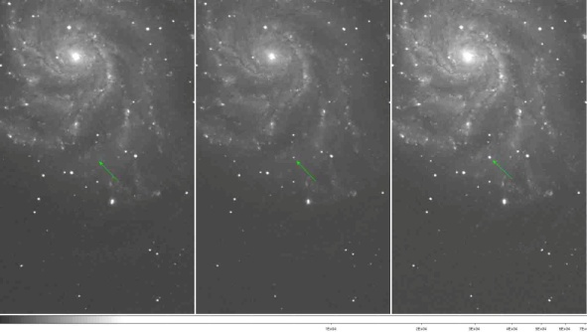

The beautiful Pinwheel Galaxy in the constellation Ursa Major (the Big Dipper) is shown the night before supernova SN 2011fe exploded on August 22, 2011 (left), half a day after it exploded (middle) on August 23, and a day later (right) on August 24 (green arrows). The supernova reached maximum brightness on September 10, 2011, and then began fading. It was both the nearest and the youngest supernova discovered by the Palomar Transient Factory, being discovered only 11 hours after it detonated.

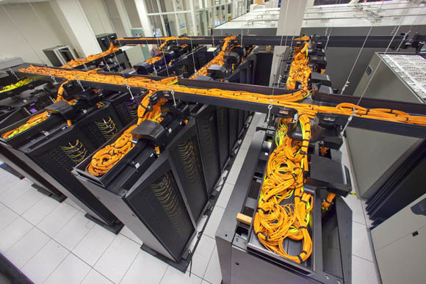

The Carver IBM iDataPlex supercomputer at NERSC at Lawrence Berkeley National Laboratory does much of the real-time analysis of images for the PTF, comparing digital images taken with the 48-inch Samuel Oschin telescope on Mount Palomar with reference images to identify supernovae. It found SN 2011fe.

